Tagasaste Direct Grazing Trial
During winter 2017, a small area of Tagasaste seedlings were planted in a specially fenced exclosure in case funding became available for further experimental work on direct grazing. Once SFF funding along with supporting agencies were on board the direct grazing trial became feasible.
The site is on slightly easier sloping ground than the main planted trial site, so there is more pronounced winter wet effect. There have been some tree losses and there could be more, so it important to get this part of the project underway.
Six pairs of trees have been selected to be grazed/ungrazed. Trees have all been cut back with hand saws and loppers to a standard height and diameter so that regrowth can begin from a similar base level between pairs. This was carried out on 17 June 2019.
The intention is that regrowth will be grazed every 3-4 months. Half the block will be grazed by cattle and the other half of the pairs will be harvested by hand in a way that mimics the browsing. This will allow us to assess the volume and value of cattle type feed.
Risks are that wet seasons will result in more tree deaths. The direct graze site is wetter than the main trial site. Ideally this part of the trial would be on better drained soils or a lower rainfall area (Hawkes Bay, Central Hawkes Bay or Marlborough), however the planting was already established prior to the project funding and logistically this is the best location.
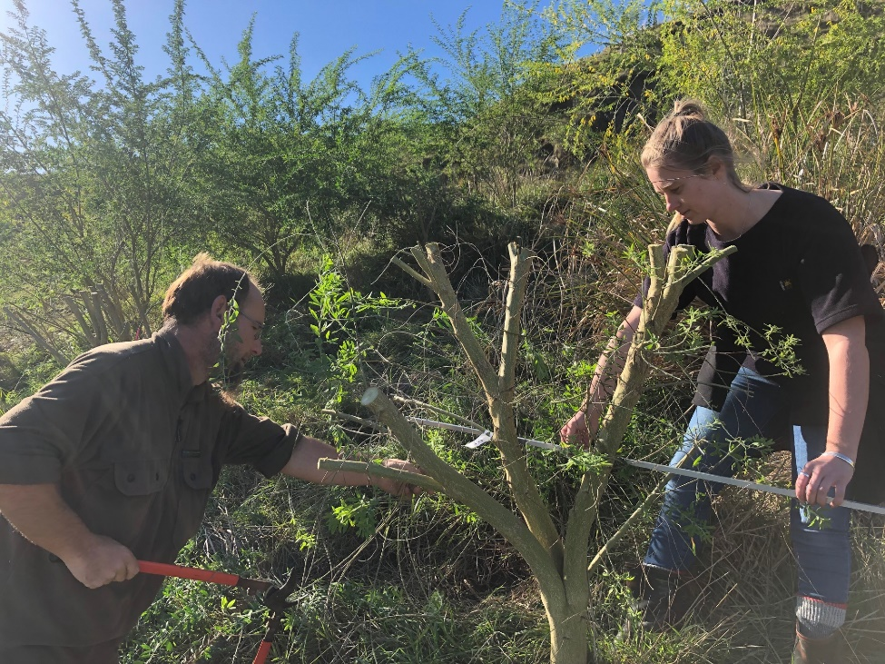
Trimming two year old trees to 1m diameter and 1.2m high to bring all trial trees to the same starting point for ‘coppice’ regrowth.

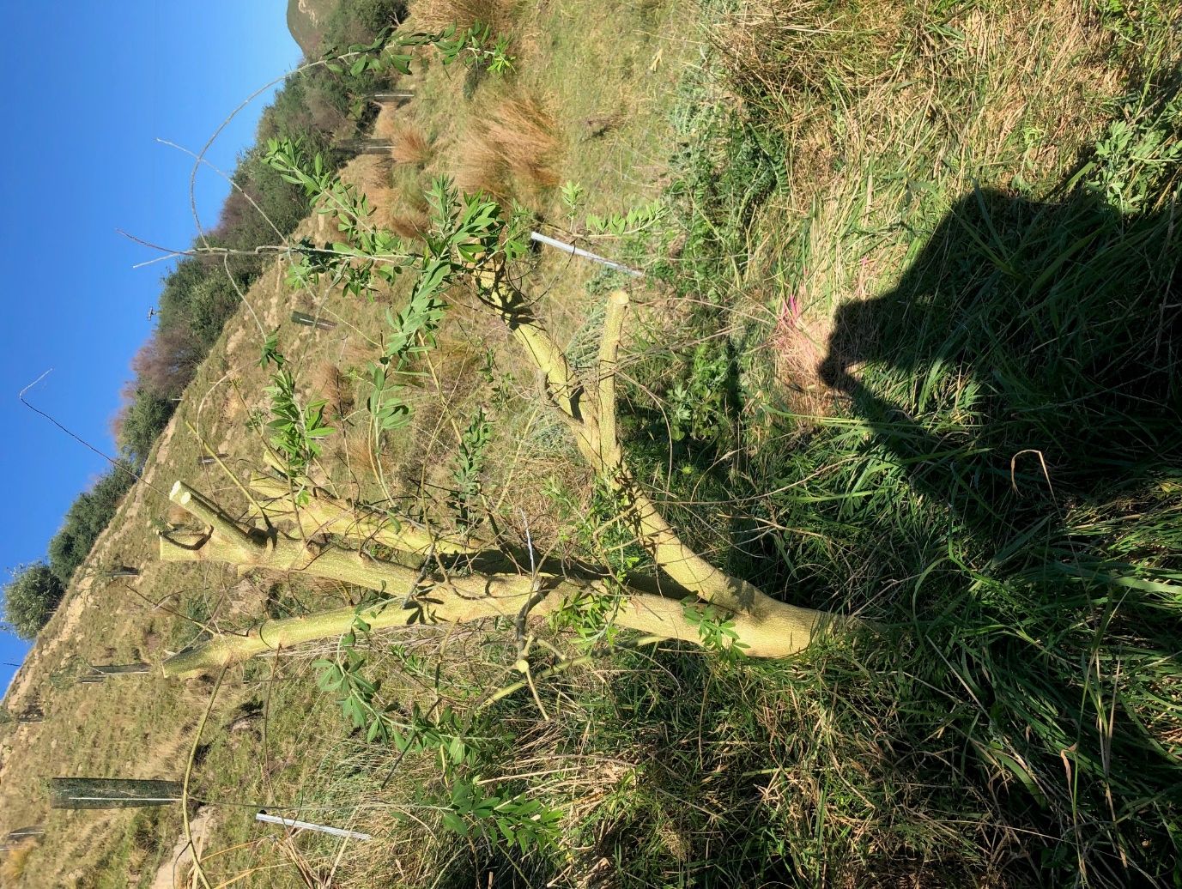
One of the 12 trimmed trees. Six pairs were selected; half to be grazed and half to be trimmed again to mimic the grazing effect. This site is stock excluded until grazing.

