Tagasaste
There is huge potential growth for the sheep and beef sector in Hawke’s Bay and the East Cape area - and for hill country in general. Around 6 million ha of hill country is too steep to cultivate but it represents 54% of the land area on which sheep and beef farming is undertaken in New Zealand, adding over $4 billion p.a. of export revenue to our economy. Topsoil is the principal “natural capital” of hill country farms and its erosion and loss represents a huge reduction in the productive potential of hill landscapes. The depleted soil is more prone to drought, more easily invaded by woody weeds, and represents a significant loss of stored carbon from the landscape.
Tagasaste is a hardy, nitrogen-fixing tree with moderate to high protein foliage suitable as forage for sheep and cattle that thrives on steep, erosion-prone, north-facing slopes. Tagasaste has the added bonus of being suitable for both the dry, shady slopes and sunny slopes, and also provides shade and shelter, has potential as a nurse plant for establishing native species, and is attractive to birds and bees.
Experiments are underway to understand how tagasaste can be incorporated into summer-dry beef and sheep hill country farm systems. This includes work on:
- Seed germination and establishment of tagasaste
- Forage production and nutritive value of tagasaste
- Weed risk assessment for tagasaste
- Production of grass and legume pasture species grown in a pasture-tagasaste system

Forage production under tagasaste – initial results
- Ryegrass, cocksfoot, microlaena, white clover, red clover and lotus plants were transplanted onto a steep north-facing slope on a farm near Wairoa on the East Coast of the North Island in August 2018 (Fig. 1)
- Species were chosen due to being drought or shade tolerant (e.g. cocksfoot, microlaena, red clover, lotus) when compared to ryegrass and white clover
- Plants were harvested to 3 cm above the ground level every 6-8 weeks

- During summer 2018-2019:
  - Cocksfoot produced at least 60% more dry matter (DM) than the other grasses (Fig. 2).
  - Lotus and red clover produced up to 300% more than white clover. However, lotus was more vigorous; red clover was more susceptible to invertebrate pest attack and diseases and mortality was greater in red clover.
  - Production of all pasture species was reduced by tagasaste shading by up to 75% (Fig. 3).

- Measurements are on-going to determine which species are the most productive and persistent when planted as a forage species mix among spaced tagasaste trees on the steep north-facing East Coast hillside.

Acknowledgements
We acknowledge the financial support of MPI in this Sustainable Farming Funded project, with generous co-funding and in-kind involvement of Beef & Lamb New Zealand, Ballance Agri-Nutrients and Hawke’s Bay Regional Council. The leadership and involvement of experienced East Coast farmers and AgResearch technicians have been invaluable.

For further information
Peter Manson: manson@hbrc.govt.nz
Grant Douglas: gbdscience@gmail.com
Katherine Tozer: Katherine.tozer@agresearch.co.nz

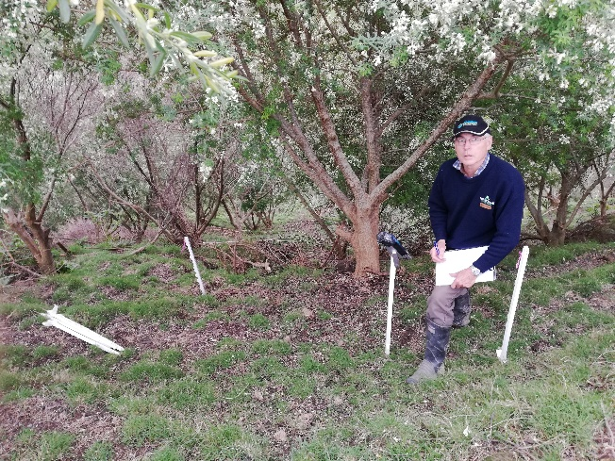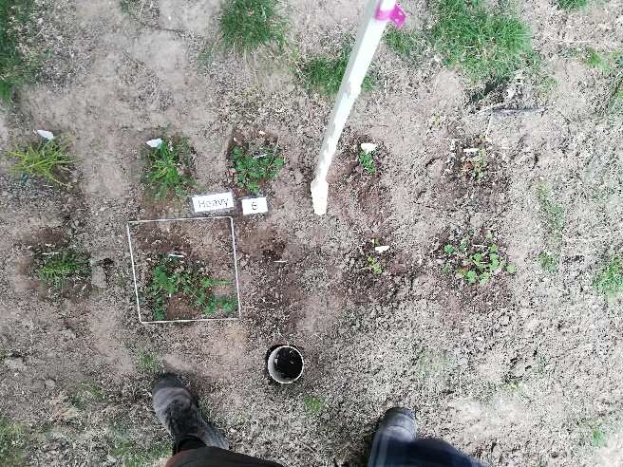
Figure 1. Tagasaste plantation (left) in which the production of a range of forage species growing under the tagasaste understory (right) and in open pasture is being quantified.

Figure 2. Dry matter production of six pasture species among spaced tagasaste trees on a steep north-facing slope near Wairoa.

Figure 3. Mean dry matter production of six pasture species grown under heavy tagasaste shade, under light tagasaste shade or in open pasture on a steep north-facing slope near Wairoa.

